# Command Prompt Course:

CLI = Command Line Interface

GUI = Graphical Line Interface

CLI is getting into files or folders by writing commands in the command prompt.

GUI is getting into files or folders by clicking mouse and seeing the icons.

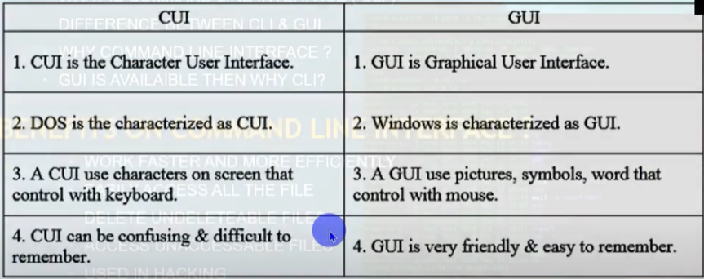

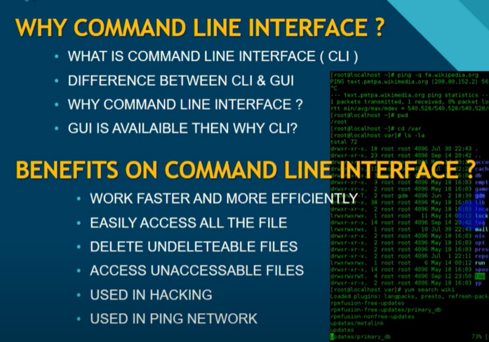

# Commands:

dir : Shows all folders, files, subfiles in which folder we currently working

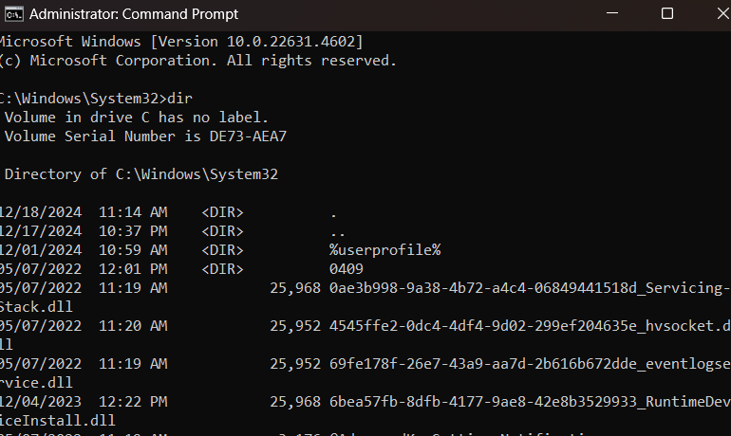

date : shows current date . we can modify date here

time : shows current time. We can modify time here

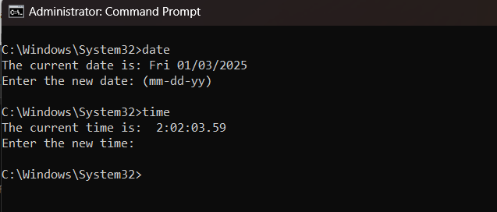

mkdir : creates a new folder in the folder currently working.

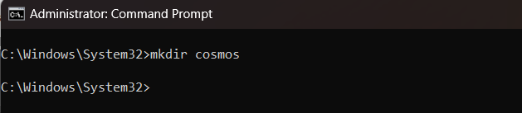

rmdir : remove directory . removes a file or folder from currently working folder

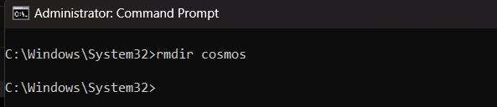

rmdir /s FOLDER_NAME : if the folder has files inside it, then the folder cannot be used by using just rmir command. A /s is written between rmdir and folder name. it deletes the whole folder with all files inside it

cls : clear screen. It clears the command prompt screen.

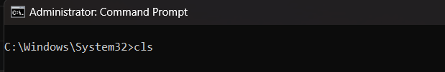

cd : change directory . it changes directory from current directory

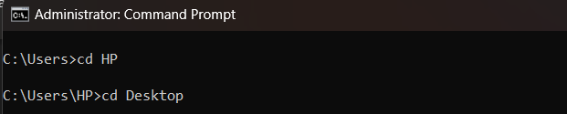

help : it provide us all useful commands

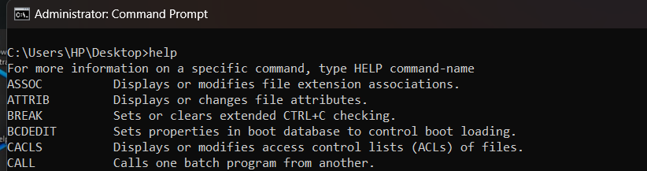

exit: closes command prompt

copy : copies any file and paste it into any folder. In the syntax , after writing copy the file is written and then the folder name where the file will be pasted is written. We can check the folder using dir if the file has been pasted or not.

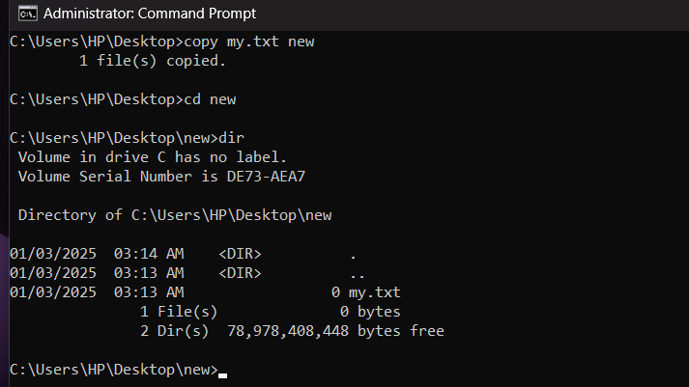

cd.. : this is used to go back from a folder. Here in this example, cd.. command is used to get back to the “Desktop” folder from “new” folder.

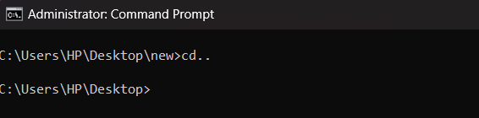

cd../.. : this is used to go back two folder.

move : it is used to move a file to any folder. In the syntax, after writing move the file name is written and then the folder name is written where the file will be moved.

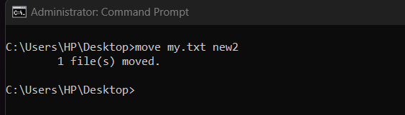

del : it is used for deleting a file inside a folder.

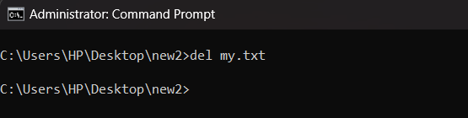

ren : it is used for rename a file name/folder name. in syntax, after writing ren the previous name is written and then the renamed name is written.

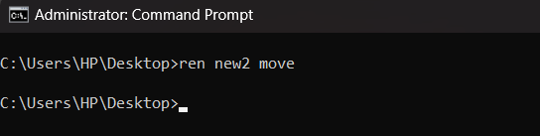

ver : for checking the windows version

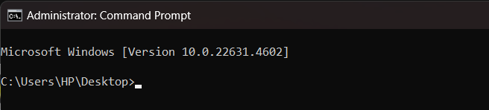

shutdown /s : shuts down the pc

shutdown -s -t 3600 : this command shuts down pc after given time. In the syntax, after writing shutdown -s is written for shutdown and then -t is written for giving time and 3600 is written in second to set time. After the time the pc will shut down.

shutdown /r : restart the pc

shutdown -r -t 60 : this command restarts pc after given time. In the syntax, after writing shutdown -r is written for shutdown and then -t is written for giving time and 60 is written in second to set time. After the time the pc will retart.

shutdown /l : log off the pc

title : changes the command panel heading as your wish

prompt : changes the directory of command prompt as your wish

color : changes the text and background of command prompt. In the syntax, after writing color the first character is for background change and the second character is for foreground change. But this all will be temporary . after exiting command prompt this all will be removed. Here some characters are shown below

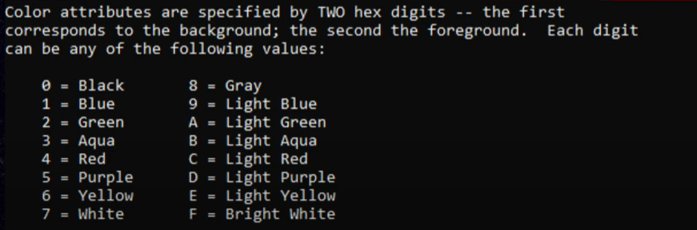

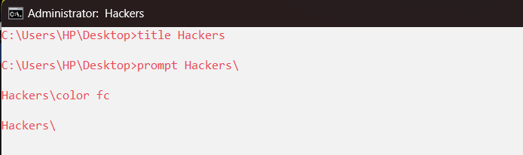

tasklist : shows the task are running in the background.

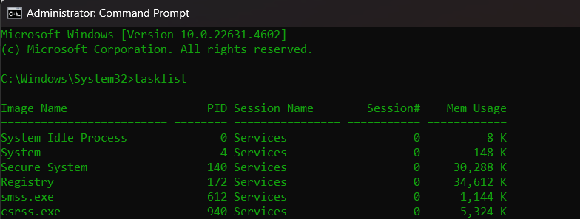

taskkill : it closes any task running in the background. In the syntax after writing taskkill a space and a slash is written and the the pid of the closing task is written

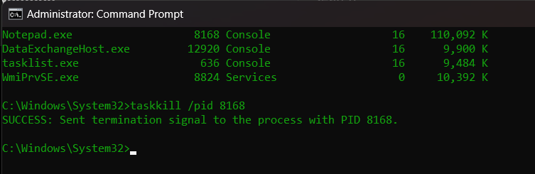

net start : starts all the services running in background

driverquery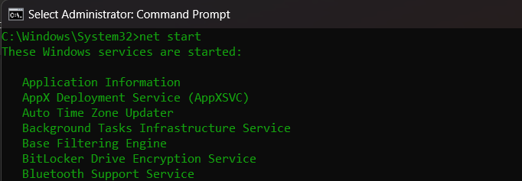

net stop “ “ : this command stops a service we want to stop. To start the service again we have to give net start “ “ again and write the service name inside the quotation.

driverquery : it shows all the driver running.

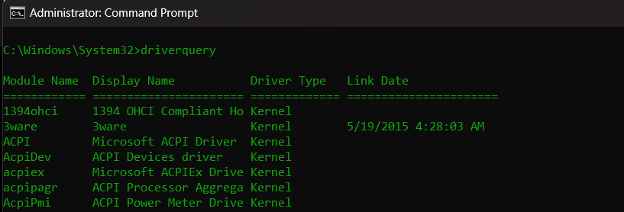

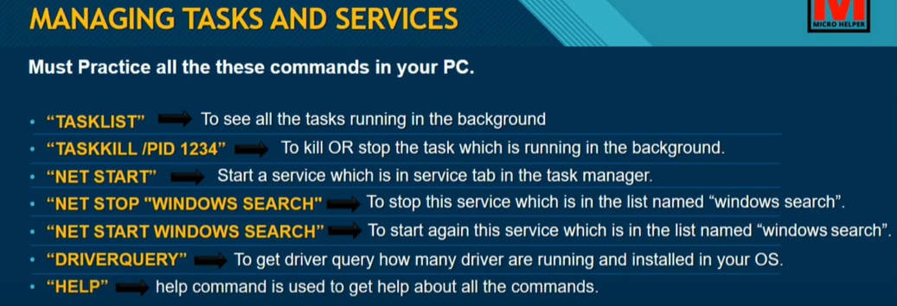

# Getting system and program info

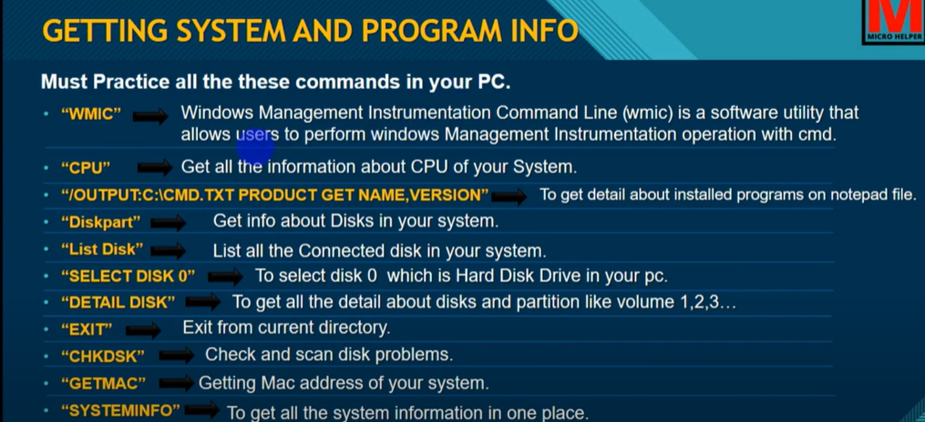

wmic : it reaches us into the root directory of current folder. We can get the all installed softwares details where we want. Here in the syntax below, ‘/output: ‘ is giving us the output we want in the directory ‘ c:\hackers.txt ‘ of the product form where we can ‘ get ‘ name and version

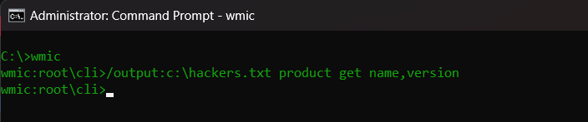

cpu : this command shows us the information of our cpu.

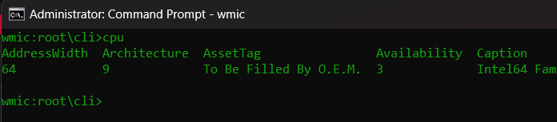

diskpart : gives us details about our disk

list disk : shows us the list of disk installed in out pc

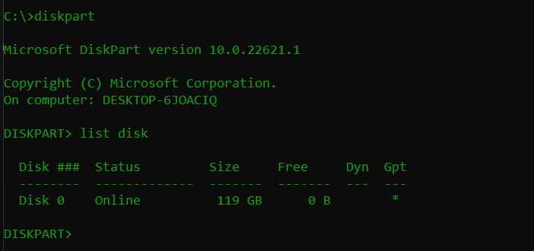

select disk : disk will be selected as our wish

detail disk : disk details will be shown

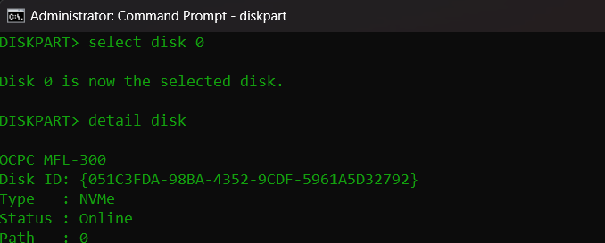

chkdsk : check the disk

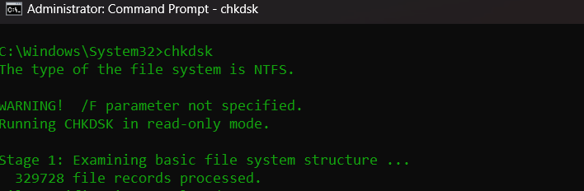

dir C:\ : making directory to local disk C. by replacing D,E,F we can get directory to them. It shows all details of that local disk

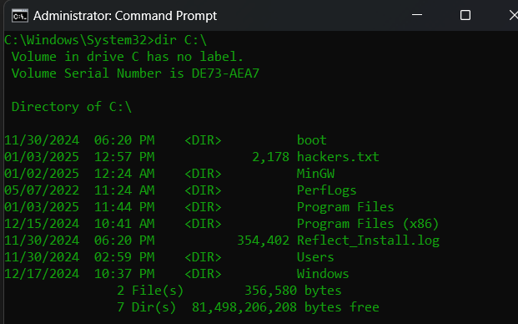

wmic logicaldisk get name, version, freespace : this command shows about localdisks. In the syntax after writing get name, version and freespace will be provided

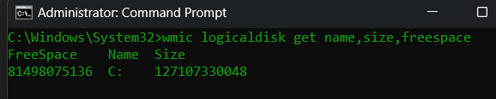

clean : this cleans the disk inside diskpart

getmac : gets mac address

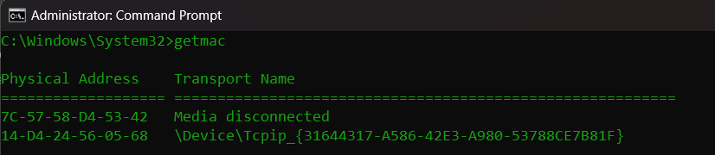

systeminfo : shows the informations of the system

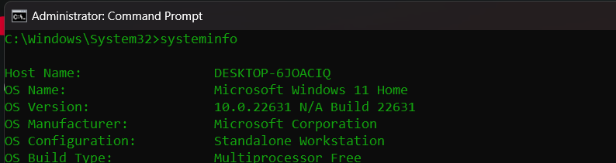

# Managing User Account:

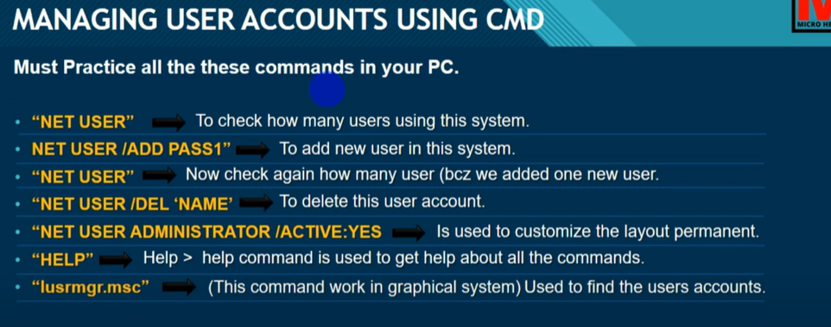

net user : shows how many users are there

net user NEW_USERNAME /add PASSWORD : if we want to add another user here this command is written. In the syntax, after writing net user new username is written, then /add is written to add this new user and then a password is set for the user

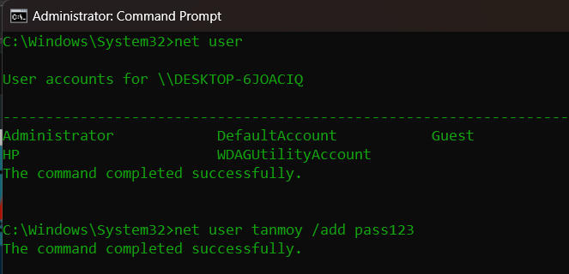

net user “administrator” : this command shows all info about administrator user

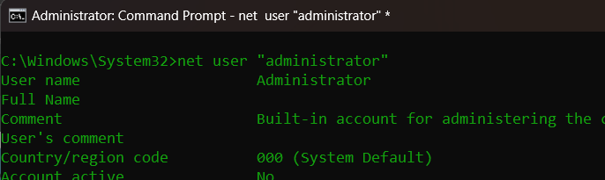

net user “administrator” * : it is used for changing password

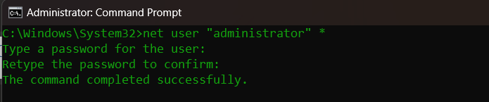

# Hide and Encrypt Files

attrib +h +r +s : this command hides any files

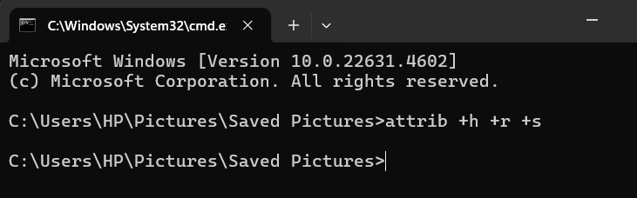

attrib -h -r -s : this command unhide the hidden files

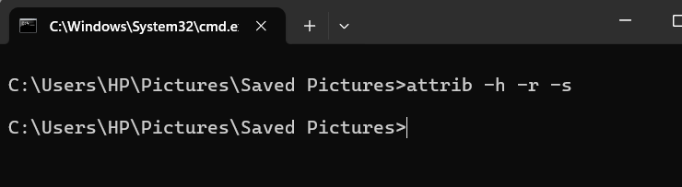

cipher /e : it is used for making some files encrypted

cipher /d : it is used for making the encrypted files decrypted

assoc.YOUR_FILE_EXTENSION : this is used to know what it means by the extension

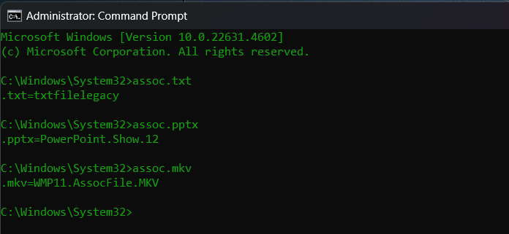

# Creating and Exporting Files:

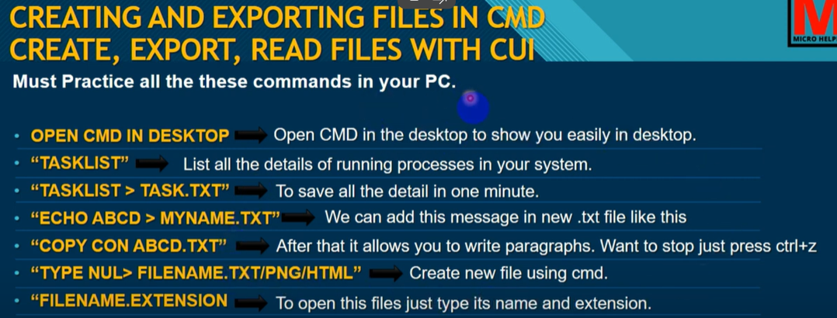

echo YOUR_TEXT > FILENAME : it enters the written text into the file

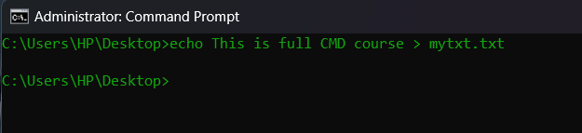

copy con FILE_NAME : it copies text in the file name. in the syntax copy means to copy, con means in console to the FILE_NAME.

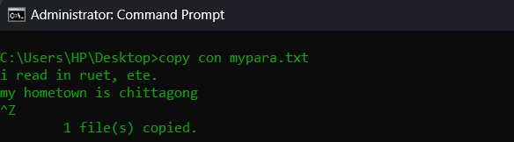

tree : this command shows all the folders and subfolders in tree shape

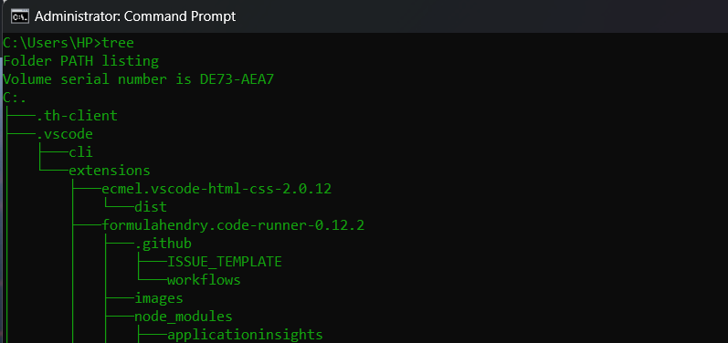

doskey/history : this command shows all the commands we put in command prompt.

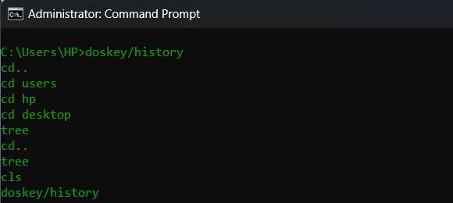

# Checking Scheduled Task:

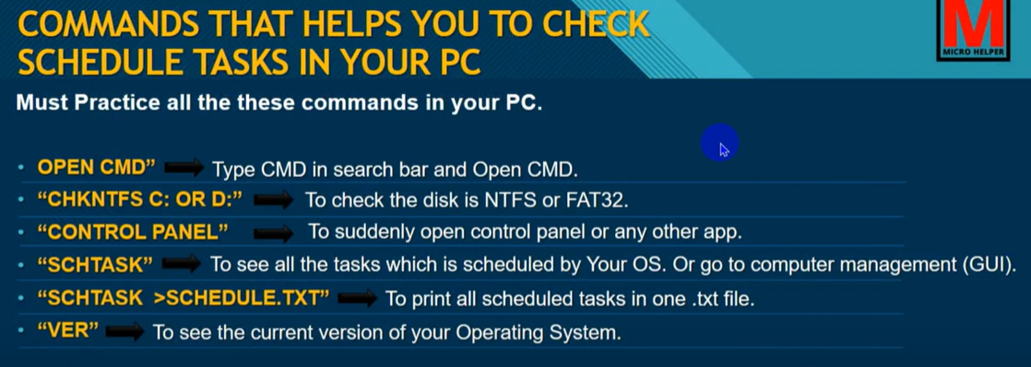

chkntfs C: : shows that C disk is ntfs or fat32

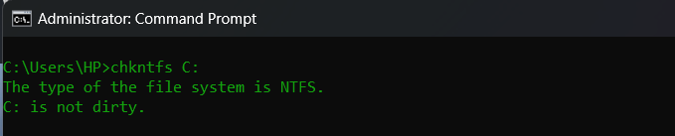

schtasks : shows all the scheduled tasks

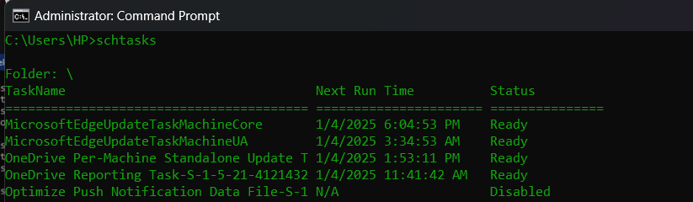

# Networking:

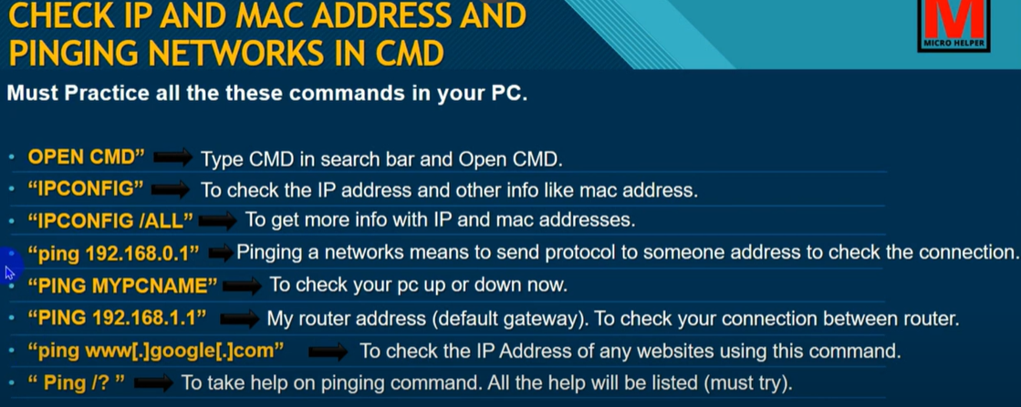

ipconfig : shows details about ip address.

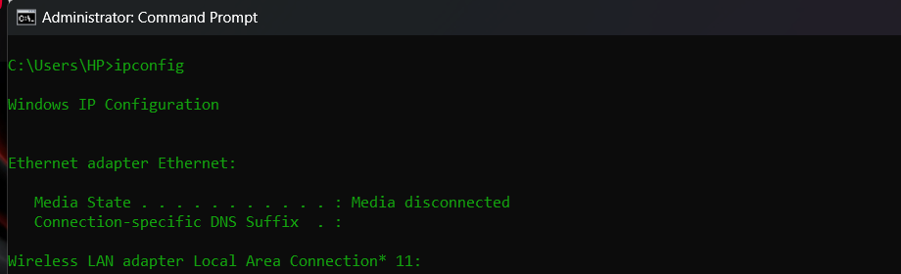

ipconfig /all : shows more details about ip address and network

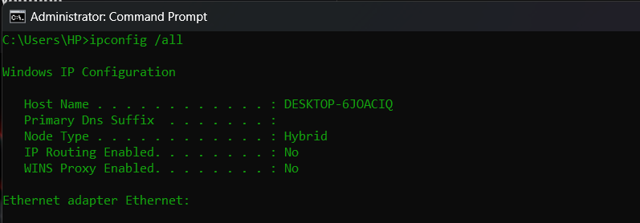

ping 192.168.0.1 : shows the connection status of pc with wifi

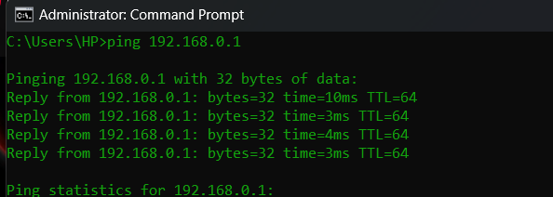

ping [www.google.com](http://www.google.com) : shows the ip address and network information of a website.

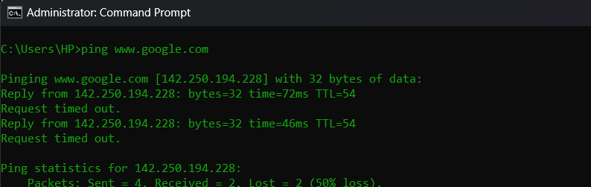

main.cpl : this command reaches us to mouse configuration

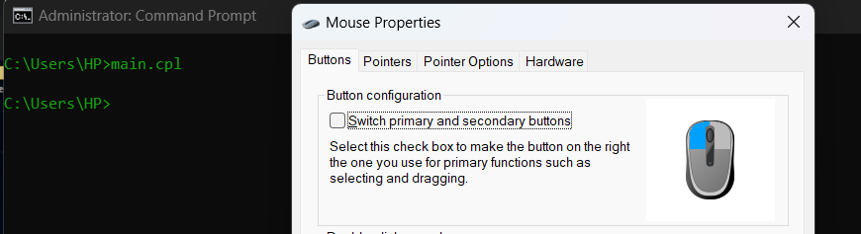

ncpa.cpl : this command reaches us to the network configuration

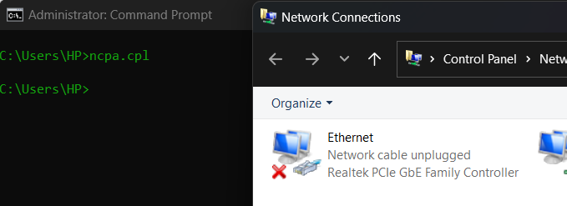

osk : this command opens on screen keyboard

msinfo32 : this command shows all informations of our pc

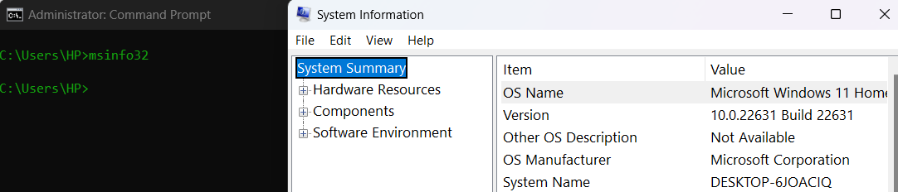

md auxa\ : creates an undeletable folder

rd auxa\ : deletes the undelatable folder

netsh wlan show profile : this command shows the names of all the wifi our pc has been connected.

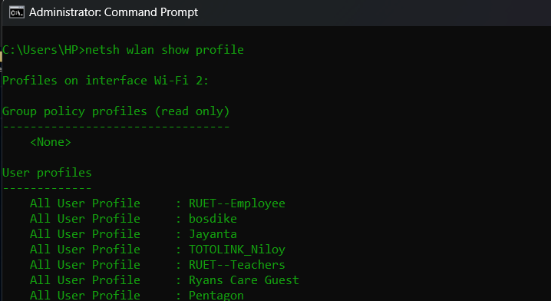

Formatting an usb and ready for work:

diskpart

list disk

select disk 1

create partition primary

select partition 1

format fs=ntfs quick

active

assign

label DISK_NAME

NEW_NAME